Area of circle
Algorithm:
- Start.
- Declare variables radius,area.
- Set the value of pi = 3.14.
- Read the Radius from the user.
- Calculate the area using the formula (area = 3.14 * radius *radius).
- Display the calculated area.
- Stop.
Flowchart:
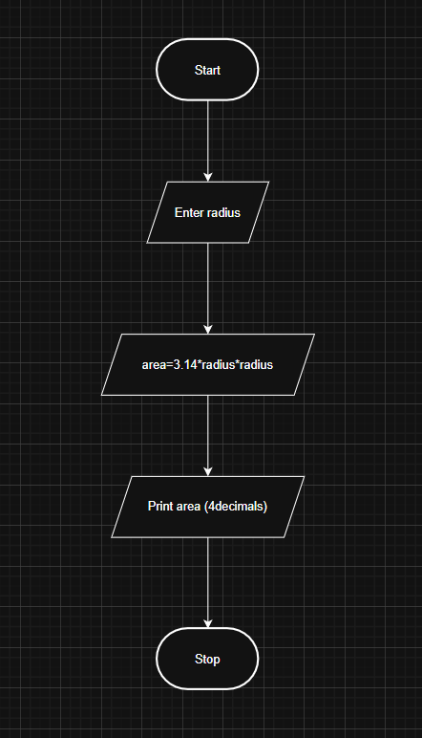
Code:
radius = float(input())
area = 3.14 * radius *radius
print(f"{area:.4f}")

Execution:

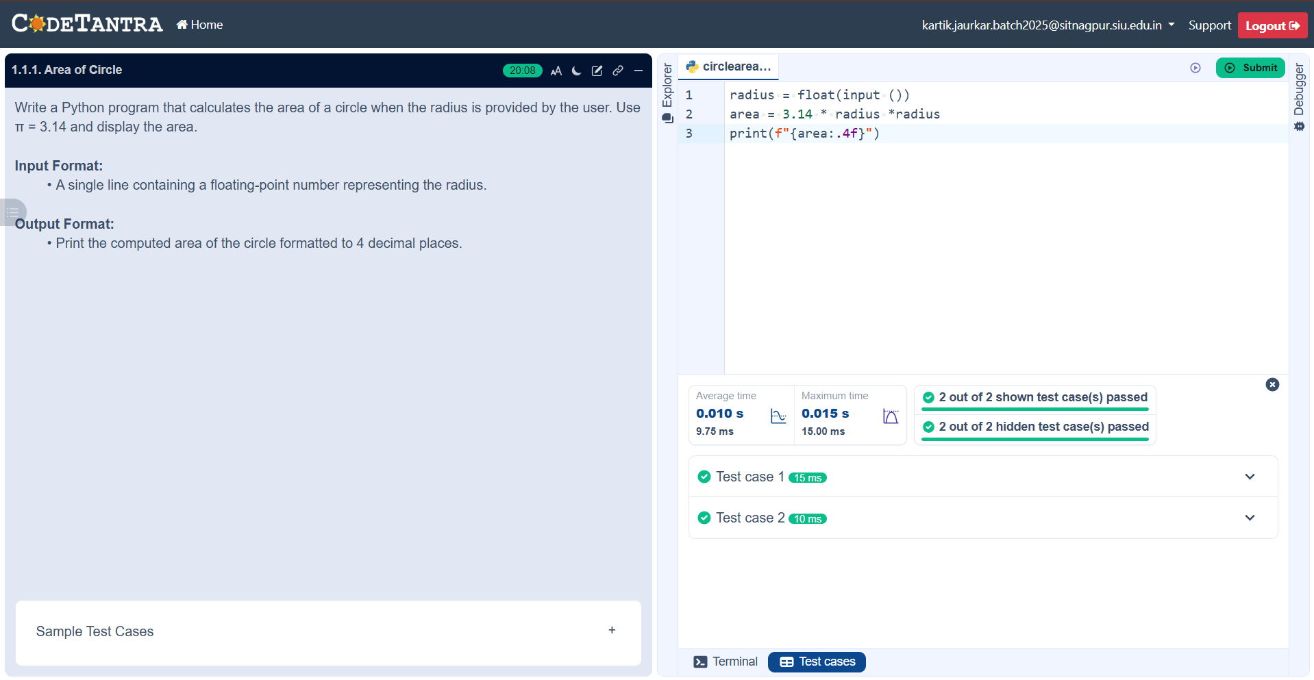

1.1.2Area of Rectangle :
Algorithm:
- Start.
- Read the length and width of rectangle from the user.
- Calculate the area using the formula( Area = length * width ).
- Display the calculated Area.
- Stop.
Flowchart:
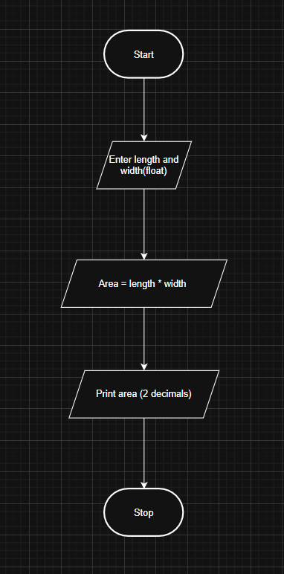
Code:
length = float(input())
width = float(input())
area = length * width
print(f"{area:.2f}")
Execution:
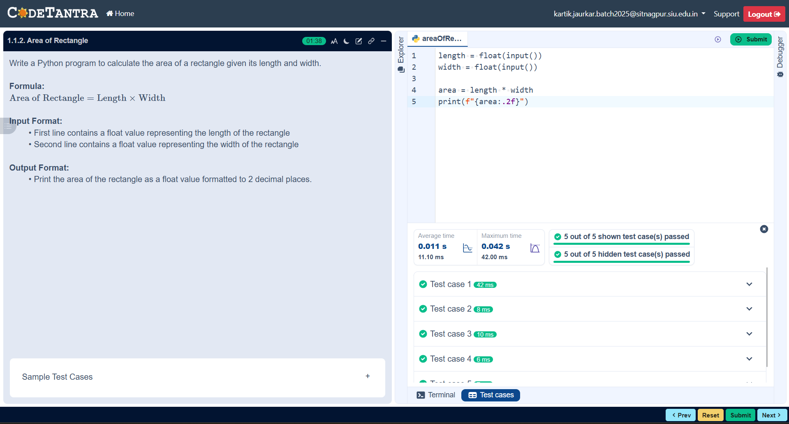

Calculate Area of Square :
Algorithm:
- Start.
- Declare variable side_length.
- Read the value of the side_length from the user.
- Calculate the area using the formula (area = side_length * side_length).
- Display the calculated area.
- Stop.
Flowchart:
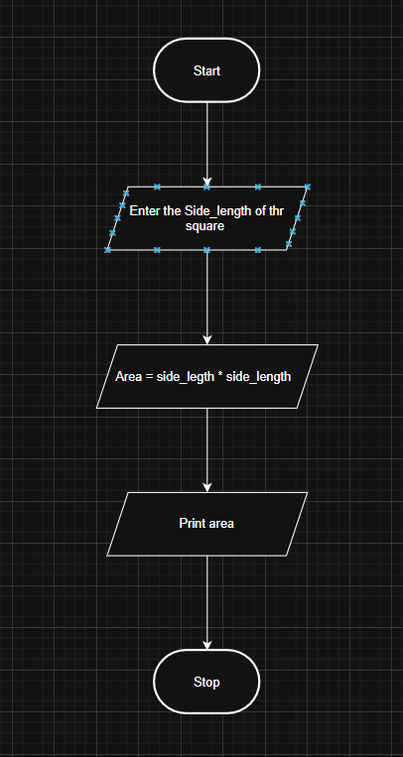

Code:
side_length = int(input())
area = side_length * side_length
print(area)
Execution:
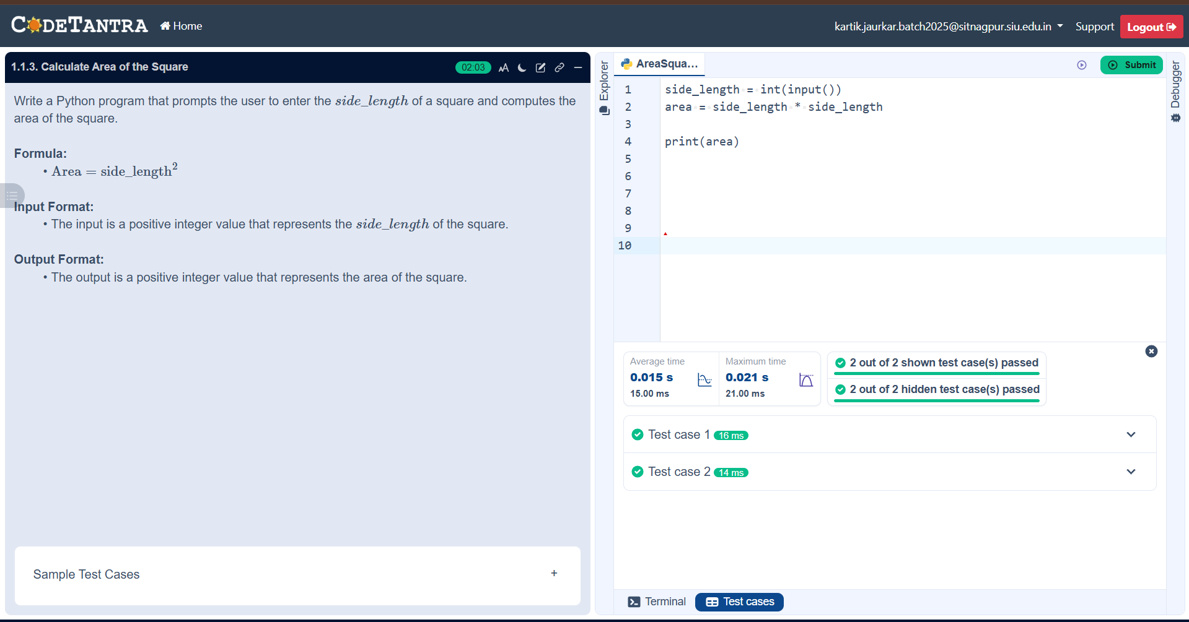

Area of Triangle:
Algorithm:
- Start.
- Declare the variables base , height , area.
- Read the value of base and height from the user.
- Calculate the area using the formula (area = 0.5 * base *height ).
- Display the Area
- Stop.
Flowchart:
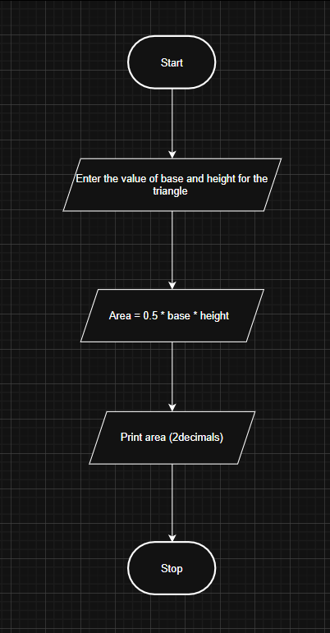
Code:
base = float(input())
height = float(input())
area = 0.5 * base * height
print(f"{area:.2f}")
Execution:
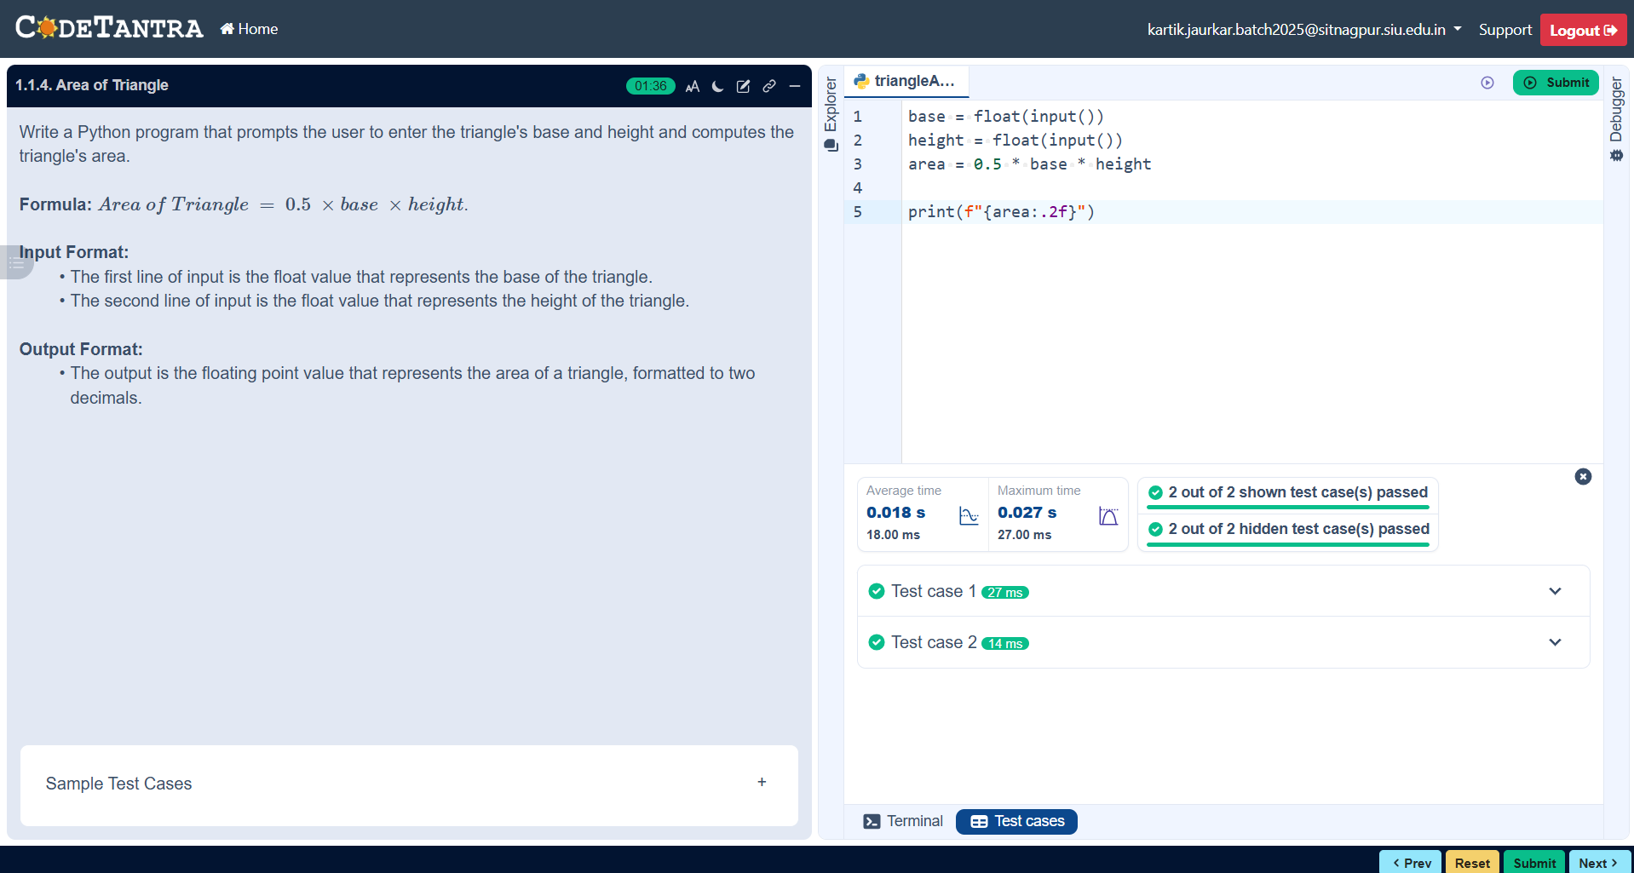

Student pass or fail Status:
Algorithm:
- Start.
- Declare variables Marks.
- Read the marks obtained by the student .
- Check condition :
- If marks >= 40 , then print “Pass”.
- Else print “Fail”
- Stop,
Flowchart:
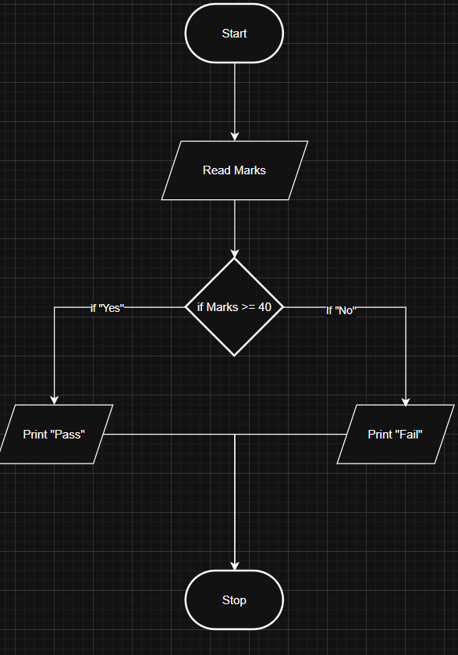
Code :
marks = int(input())
if marks >= 40:
print("Pass")
else:
print("Fail")
Execution:
